Battle HUD

The Battle HUD is quite short, and its function is to set information onto a panel in the UI of the project. It is attached to the Player and the Enemy HUDs and operates with two text boxes and a slider. The class is using Unity UI systems.

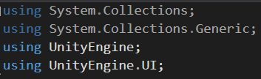

First are the references to the UI elements that it uses.

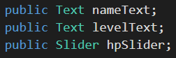

Then two voids, starting with a set up as the battle starts. It calls for the information stored into the Unit script explained in Tutorial #2 and fill it into the reference elements of the UI.

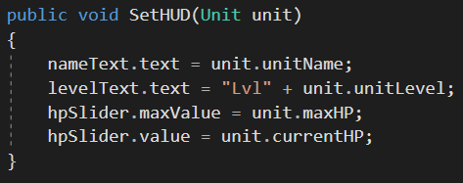

As we can see in the picture above, the data stored in the Unit class is being filled in the text boxes for Unit Name and Unit Level. I little adjustment is made for Unit Level where is added the “Lvl” text before the actual information coming from the Unit scrip. This is followed by the two references to the maximum Hit Points and the control over the Current Hit Points. The last part of the scrip manages the updating of the Hit Points Slider in the UI.

